SECTION –B MANAGEMENT
UNIT 4. Introduction to Management
Definitions and importance of management:-
Management is an inevitable element for directing and unifying the group efforts towards a common objective. Since the most of the human aims can be well realized only through collective action, management is universally called for in all such organizations of the society.In short, management is not merely the task of managing the business. But it is an essential accompaniment of all social organizations and is to be found everywhere as a distinct and dominant activity.
In other words, management functions have universal application. While describing the pivotal role of management in the social history, Drucker rightly remarked that
With the growth of industry and commerce and the separation of ownership from control, management has become more or less a profession.
Management, today, consists of a cadre of professionalists and is concerned not only with the initial formation of the enterprise but also with the problems of adapting, expanding or contracting the firm whenever changing economic conditions and environmental influences require such action.
It provides new ideas, imaginations and visions to the group working so as to account for better results or performances. It ensures a smooth flow of work in the organization by focusing on strong points, neutralizing weak links, overcoming difficulties and establishing team spirit.

Role of Management
In any organizational unit, whether it is a company or a section in a company, the manager stands between his organization and its environments.
Today, the society has become very complex and a change in one part generates changes in other parts. Changing technology has created complexities which call for improved managerial practices. The age of specialization poses problems of coordination and the job of the manager becomes more complicated and magnified. Business has also become more complicated on account of increased Government control.

Importance of Management

1. Meeting the Challenge of Change
Challenge of change has become intense and critical in recent years. The complexities of modern business can be overcome only through scientific management.

2. Effective Utilization of the Seven M’s
There are seven M’s in business, such as Men, Materials, Money, Machines, Methods, Markets and Management. Management stands at the top of all these M’s and determines and controls all other factors of business.

3. Directs the Organization
Just as the mind which directs and controls the body to fulfill its desires, management also directs and controls the organization to achieve the desired goal

4. Integrates Various Interests
In the group efforts, there are various interest groups which put pressure over other groups for maximum share in the final output. Management by balancing these pressures integrates the various interests.

5. Provides Stability
It provides stability in the society by changing and modifying the resources to cope up with the demanding needs of the every changing environment of the society.

6. Provides Innovation
Management provides new ideas, imaginations and visions to the organization and necessary life for better and greater performance.

7. Establishes Team-spirit
Management coordinates the activities of the various departments in an organization and establishes team-spirit among the personnel.

8. Tackles Business Problems
Good management serves as a friend, philosopher and guide in tackling business problems. It provides a tool for the best way of doing a task.

9. Acts as a Tool of Personality Development
Management is not the direction of things, but the development of men. It makes the personality of the people. Management strives to improve quality, efficiency and productivity.

Functions of management: Importance and Process of planning, organising, staffing,directing and controlling:-

Planning:-It is the basic function of management. It deals with chalking out a future course of action & deciding in advance the most appropriate course of actions for achievement of pre-determined goals. According to KOONTZ, “Planning is deciding in advance - what to do, when to do & how to do. It bridges the gap from where we are & where we want to be”. A plan is a future course of actions. It is an exercise in problem solving & decision making. Planning is determination of courses of action to achieve desired goals. Thus, planning is a systematic thinking about ways & means for accomplishment of pre-determined goals. Planning is necessary to ensure proper utilization of human & non-human resources. It is all pervasive, it is an intellectual activity and it also helps in avoiding confusion, uncertainties, risks, wastages etc.

Organizing
It is the process of bringing together physical, financial and human resources and developing productive relationship amongst them for achievement of organizational goals. According to Henry Fayol, “To organize a business is to provide it with everything useful or its functioning i.e. raw material, tools, capital and personnel’s”. To organize a business involves determining & providing human and non-human resources to the organizational structure. Organizing as a process involves:
  - Identification of activities.
  - Classification of grouping of activities.
  - Assignment of duties.
  - Delegation of authority and creation of responsibility.
  - Coordinating authority and responsibility relationships.

Staffing
It is the function of manning the organization structure and keeping it manned. Staffing has assumed greater importance in the recent years due to advancement of technology, increase in size of business, complexity of human behavior etc. The main purpose o staffing is to put right man on right job i.e. square pegs in square holes and round pegs in round holes. According to Kootz & O’Donell, “Managerial function of staffing involves manning the organization structure through proper and effective selection, appraisal & development of personnel to fill the roles designed un the structure”. Staffing involves:
  - Manpower Planning (estimating man power in terms of searching, choose the person and giving the right place).
  - Recruitment, Selection & Placement.
  - Training & Development.
  - Remuneration.
  - Performance Appraisal.
  - Promotions & Transfer.

Directing
It is that part of managerial function which actuates the organizational methods to work efficiently for achievement of organizational purposes. It is considered life-spark of the enterprise which sets it in motion the action of people because planning, organizing and staffing are the mere preparations for doing the work. Direction is that inert-personnel aspect of management which deals directly with influencing, guiding, supervising, motivating sub-ordinate for the achievement of organizational goals. Direction has following elements:
  - Supervision
  - Motivation
  - Leadership
  - Communication
Supervision- implies overseeing the work of subordinates by their superiors. It is the act of watching & directing work & workers.
Motivation- means inspiring, stimulating or encouraging the sub-ordinates with zeal to work. Positive, negative, monetary, non-monetary incentives may be used for this purpose.
Leadership- may be defined as a process by which manager guides and influences the work of subordinates in desired direction.
Communications- is the process of passing information, experience, opinion etc from one person to another. It is a bridge of understanding.

Controlling
It implies measurement of accomplishment against the standards and correction of deviation if any to ensure achievement of organizational goals. The purpose of controlling is to ensure that everything occurs in conformities with the standards. An efficient system of control helps to predict deviations before they actually occur. According to Theo Haimann, “Controlling is the process of checking whether or not proper progress is being made towards the objectives and goals and acting if necessary, to correct any deviation”. According to Koontz & O’Donell “Controlling is the measurement & correction of performance activities of subordinates in order to make sure that the enterprise objectives and plans desired to obtain them as being accomplished”. Therefore controlling has following steps:
  - Establishment of standard performance.
  - Measurement of actual performance.
  - Comparison of actual performance with the standards and finding out deviation if any.
  - Corrective action.

Principles of management (Henri Fayol, F.W. Taylor):-

Definition of Henry Fayol’s Theory of Management
Henry Fayol, renowned as ‘father of modern management theory’, as he introduced comprehensive thinking on management philosophy. He put forward general management theory that applies to every organization equally and in every field. The principles of management laid down by Fayol are used by managers to coordinate the internal activities of the company.
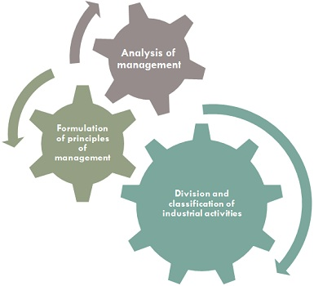
To put into practice, the three components, i.e. division and classification of industrial activities, analysis of management and formulation of principles of management, Fayol promulgated fourteen principles of management, which are listed below:
- Division of Work: Work is divided into small tasks or jobs, which results in specialization.
- Authority and Responsibility: Authority implies the right to give the command and obtain obedience and responsibility is the sense of dutifulness, that arises out of authority.
- Discipline: Discipline refers to obedience to organizational rules and the terms of employment. It is to ensure compliance and respect for seniors.
- Unity of Command: An employee will receive orders from one boss only.
- Unity of Direction: All the organizational units should work for the same objectives through coordinated efforts.
- Subordination: Individual or group interest are sacrificed or surrendered for general interest.
- Remuneration: Fair and satisfactory payment for both employer and employee.
- Centralization: There must be the optimum utilization of organization’s resources.
- Scalar Chain: Scalar chain implies the superior-subordinate relation, within the organization.
- Order: In an organization, there must be a proper place for every thing as well as each thing must be in its appointed place.
- Equity: Sense of equity should exist at all the levels of the organization.
- Stability of tenure of Personnel: Efforts are to be made to reduce employee turnover.
- Initiative: It implies thinking out and implementation of the plan.
- Esprit de Corps: It stresses on the need of team work in the organization.

Definition of F.W. Taylor’s Theory of Management
Fredrick Winslow Taylor, or F.W. Taylor popularly known as ‘father of scientific management’ who with the help of experiments proved that scientific methodology could be applied to management. A scientific process comprises of observations, experiments, analysis and inferences, which Taylor wants to apply in management to develop a cause and effect relationship.
Taylor’s primary concern was management at the supervisory level and gave much stress on the efficiency of workers and managers at an operational level. Scientific Management is just a mental revolution for both employer and employees, which consist of the following principles:
- Science, not the rule of thumb: To improve the performance level, the rule of thumb is replaced by science.
- Harmony, not discord: There must be a coordination of the activities of the employees and not discord.
- Cooperation, not individualism: There should be an environment of cooperation in the organization, of mutual interest.
- Development of every person to his greatest efficiency: Motivation is to be provided to greatest efficiency to every member of the organization.
Concept and structure of an organisation:-

What is Organizational Structure?
Organizational structure helps a company assign a hierarchy that defines roles, responsibility, and supervision. It’s the plan that outlines who reports to whom and who is responsible for what. It’s usually recorded and shared as an organizational chart that includes job titles and the reporting structure.

Structure Types
Organizational structures typically use one of two approaches:
- A centralized structure gives most of the authority and decision-making power to the team at the top.
- A decentralized structure distributes authority and decision-making power at lower levels, which might include departments, groups, or business units.
A company can be organized in a number of ways. It might be built around divisions, functions, geography, or with a matrix approach:
- A divisional structure is organized around divisions or business units that are self-contained entities with their own functional departments such as human resources, marketing, and so on.
- A functional structure is based on job functions often labeled as departments – finance, purchasing, etc.
- A geographical structure is often used when a company has multiple locations. Each location operates independently.
- With a matrix structure, the company is organized around teams assembled for specific tasks. Team members usually report to more than one person – the team leader, and the supervisor for the team member’s functional area.
The organizational structure of a small business is most likely functional – one based on job duties. While small businesses are often casual with their hierarchy, some type of organizational structure is required so that employees know who is supervising their work and can help with problem-solving and other issues. That structure also helps them understand growth potential in their jobs. In addition, an expanding business can minimize growing pains when it has an organizational structure or hierarchy in place to build on during growth periods.
Types of industrial organisations
a) Line organisation
b) Line and staff organisation
c) Functional Organisation
The adoption of a particular form of organisational structure largely depends upon the nature, scale and size of the business. The organisational structure is primarily concerned with the allocation of activities or tasks and delegation of authority.

1. Line Organisation:
Line organisation is the simplest and the oldest type of organisation. It is also known as scalar organisation or military type of organisation. In the words of J.M. Lundy, “It is characterized by direct lines of authority flowing from the top to the bottom of the organizational hierarchy and lines of responsibility flowing in an opposite but equally direct manner.”
An important characteristic of such type of organisation is superior-subordinate relationship. Superior delegates authority to another subordinate and so on, forming a line from the very top to the bottom of the organisation structure. The line of authority so established is referred as “line authority.” Under this type of organisation authority flows downwards, responsibility moves upwards in a straight line. Scalar principle and unity of command are strictly followed in line organisation.
This type of organisation resembles with the army administration or military type of organisation. As in case of military, commander-in-chief holds the top most position and has the entire control over the army of the country, which in turn is developed into main area commands under major-generals.
Each area has brigade under brigadier-generals, each brigade is fabricated into regiments under its colonels, each regiment into battalions under majors, each battalion into companies under captains, each company sub-divided under its lieutenants and so on drawn to corporal with his squad.
Types of line organization:
Line organisation is of two type’s viz. (a) Simple or Pure Line Organisation (b) Departmental Line Organisation

2. Functional Organisation:
F.W. Taylor, who is better known as the father of scientific management developed the concept of ‘Functional Organisation’. As the very name suggests, functional organisation implies that the organisation should be based on various functions. Taylor’s functional approach is mainly based on principle of specialization and tries to bring about organisational balance.
The principle of specialisation embodies the concept that both the workers and the supervisors can develop a higher degree of proficiency by separating the manual from the mental requirements. Taylor recommended that there should be functionalisation even at the shop level where workers have to produce goods. He felt that the usual practice of putting one foreman incharge of some 40 to 50 workers should be avoided.
Taylor’s concept of Functional Foremanship (as he puts it), is a system comprising of eight different foremen discharging different functions. Every worker in the organisation is directly connected with these foremen.
The eight specialist foremen are:
(a) Route Clerk, (b) Instructions Card Clerk, (c) Time and Cost Clerk, (d) Shop Disciplinarian, (e) Gang Boss, (f) Speed Boss, (g) Repair Boss, and (h) Inspector. The first four bosses operate from Planning Department, whereas the other four are known as Executive Functional Bosses. They function in the production department.
A brief explanation of these eight functional foremen is given below:

(a) Route clerk:
He lays down the exact path or route to be followed by raw material transforming it into finished product.

(b) Instruction card clerk:
He prepares detailed instructions to be followed in doing the work as per the route laid down by the route clerk.

(c) Time and cost clerk:
He determines the total time to be taken in the completion of a product and also works out the cost of production per unit and total cost. He prepares various work schedules and cost sheets in order to have proper control over time and cost incurred in producing goods.

(D) Shop disciplinarian:
He is responsible for maintaining proper discipline in the organisation. In fact, he is the guardian of orderliness in the factory. In the words of Kimball and Kimball Jr. “The shop disciplinarian is responsible for discipline and good order, fie is also the peacemaker and assists in adjusting wages.”
He is helpful in resolving minor disputes regarding wages, holidays, working conditions and hours of work etc. He initiates a proper code of conduct in the organisation.

(e) Gang boss:
He makes the availability of different machines and tools required by workers to carry out their work. He also provides various production designs, drawings, raw materials etc.

(f) Speed boss:
He controls the speed of different machines operating in the organisation. He sometimes demonstrates the workers the proper speed with which the machines should operate. He undertakes proper supervision over speed of machines.

(g) Repair boss:
He is concerned with proper maintenance and repairs of machines for keeping them in working order. In the words of Spriegel, “His job of maintenance includes cleaning the machine, keeping it free from rust and scratches, oiling it properly and preserving the standards which have been set up for the auxiliary equipment connected with the machine such as belts, counter shafts and clutches.” His main task is to undertake immediate repair of the defective machines so that the work may not suffer.

(h )Inspector:
He checks and certifies the quality of work i.e., whether or not it is up to pre-determined standards. Achievement of pre-set standards is confirmed by the inspector. He develops the feeling of quality consciousness among the workers. In order to carry out his job effectively, an inspector must possess proper knowledge and the technicalities involved in quality control.
The following diagram shows Taylor’s Functional Foremanship:
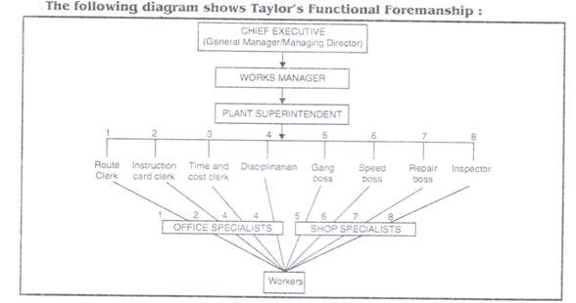
While developing the concept of Functional Foremanship, F.W. Taylor suggested that it is unscientific to overload a foreman with entire responsibility of running a department. He advocated that direction of work should be decided by functions and not be mere authority.
He thought that to be successful in performing his duties a foreman should possess various qualities viz., education, special or technical knowledge, manual dexterity or strength, tact, energy, honesty, common sense and good health”.
Spriegel has nicely explained Functional Organization. “Each worker, instead of coming into contact with one superior, would receive his orders from a group of specialised supervisors, each of whom performs a particular function.”
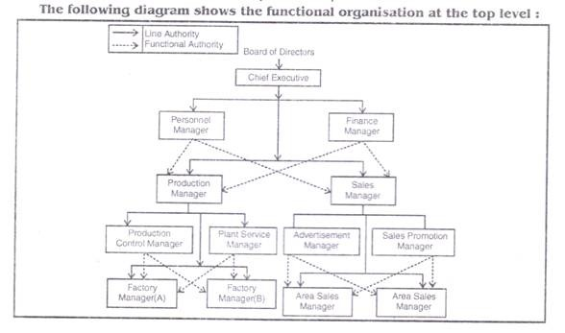
Functional organisation also operates at higher level of management. The whole work in the organisation is divided in various departments. Similar type of work and transactions are put in one department under the control of a departmental manager or head. Various departments are also known as functional areas of management viz., Purchases, Sales, Finance, Production, and Personnel etc. The respective managers of these departments will be responsible for carrying out various activities of their departments in the organisation.
For example, marketing manager will be responsible for carrying out marketing activities and personnel manager will be responsible for looking after the personnel matters in all the departments of the organisation.
The underlying idea of functional organisation at the top level of management is that a subordinate anywhere in the organization will be controlled and commanded directly by number of managers operating in different departments.

3. Line and Staff Organisation:
The line and staff organisation is an improvement over the above mentioned two systemsviz, line organisation and functional organisation. The line organisation concentrates too much on control whereas the functional system divides the control too much.
The need was, therefore, for a system that will ensure a proper balance between the two. The need has been fulfilled by line and staff organisation. The system like line organisation also owes its birth to army.
The commanders in the field who are line officers are assisted by the staff that helps them in formulating strategies and plans by supplying valuable information. Similarly in organisation, line officers get the advice of the staff which is very helpful in carrying on the task in an efficient manner. However, staff’s role is advisory in nature. Line officers are usually assisted by staff officers in effectively solving various business problems.
The staff is usually of three types viz:

(a) Personal Staff:
This includes the personal staff attached to Line Officers. For example, personal assistant to general manager, secretary to manager etc. The personal staff renders valuable advice and assistance to Line Officers.
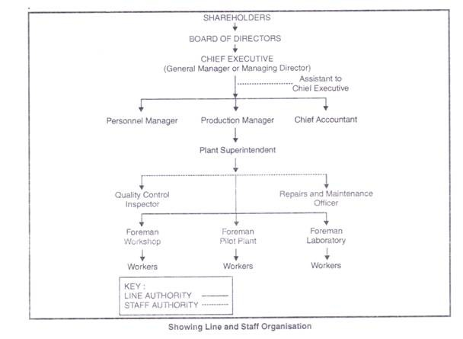

(b) Specialised Staff:
This category includes various experts possessing specialised knowledge in different fields like accounting, personnel, law, marketing, etc. They render specialised service to the organisation.
For example, a company may engage a lawyer for rendering legal advice on different legal matters. Similarly, it may engage a chartered accountant and a cost accountant for tackling accounting problems.

(c) General Staff:
This comprises of various experts in different areas who render valuable advice to the top management on different matters requiring expert advice.

Advantages of Line and Staff Organization
Important advantages of Line and Staff Organisation are:
1. Specialisation:
This type of organisation is based on planned specialisation and brings about the expert knowledge for the benefit of the management.
2. Better decisions:
Staff specialists help the line manager in taking better decisions by providing them adequate information of right type at right time.
3. Lesser Burden on line officers:
The work of the line officers is considerably reduced with the help of staff officers. Technical problems and specialised matters are handled by the Staff and the routine and administrative matters are the concern of Line Officers.
4. Advancement of research:
As the work under this type of organisation is carried out by experts, they constantly undertake the research and experimentation for the improvement of the product. New and economical means of production are developed with the help of research and experimentation.
5. Training for line officer:
Staff services have proved to be an excellent training medium for Line Officers.

